NatiFine SA
Digital Traffic Fines System
Project Name: NatiFine SA – Digital Traffic Fines System.
Group Members: Asande Mazibuko (402311204)
Lesego Mokoena (402412814)
Ofentse Mathebe (402413228)
Due Date: 18 September 2026

2. Planning Phase
Phase 2 of the NatiFine SA project will be covering the identification of need preliminary investigation, feasibility study, project planning, scheduling, software requirement specification and data modelling that underpin the system’s design and development.

2.1 Identification of Need
Traffic fine administration in South Africa is currently spread across many different municipalities, each of which is run on their own system with little or no integration between them. Fines are usually linked to a motorist’s residential address rather than their ID number which means fines are frequently missed, avoided, sent to outdated addresses and can only be discovered when a motorist tries to renew a driver’s license. In which this creates frustrations for citizens, backlogs for municipal offices and lost revenue for the local government. Therefore, there is a need for a centralized ID-linked digital platform that lets the motorists know and check for the fines as soon as they are given which allows the fines to be viewed and paid or disputed online and automatically manages reminders and license-status flags. NatiFine SA is proposed to address this need as an academic prototype demonstrating these core capabilities.

2.2 Preliminary Investigation
A preliminary investigation was conducted to confirm that the problem is real and worth solving, and that a prototype solution is achievable within the projects scope and timeframe. This investigation involved:
- Reviewing how the existing South African systems, for example, municipal e-services portals and the national AARTO framework which currently handle fine issuing, notification and payment, and identifying their gaps particularly the lack of a single ID-based view of a motorist's fines.
- Considering informal feedback from motorist’s common complaints like fines discovered late, at license renewal or sent to the wrong address so to confirm the problem described in in the Phase 1 proposal is representative of real user frustrations.
- Confirming that the three-person team has the Python, HTML/CSS and JavaScript skills required to build a working prototype within the 10-week Agile schedule.
- Establishing the boundaries of the investigation in which the prototype will simulate and not integrate with live government, banking and SMS/WhatsApp systems, keeping the scope realistic for an academic project.
The investigation that was carried out confirmed that the project is both necessary and achievable and that proceeding to a full feasibility study and planning phase is justified.

2.3 Feasibility Study(Technical, Operational, Economic)
Technical: The system uses Python, HTML/CSS and JavaScript technologies in which the group members are already familiar with these languages and for which extensive free documentation, libraries and hosting options exist. A prototype database for example, SQLite which removes the need for costly server infrastructure. The technical feasibility is within the 10-week timeframe.
Operational: The system replaces the manual address based fine tracking with an ID linked online record that motorists can check, pay and dispute at any time to municipal offices and reduces the chance of motorists being unaware of fines. As a prototype it will simulate notifications and payments rather than connect to live banking and government systems which keep operations realistic without regulatory risk.
Economic: All the chosen tools (Python, HTML/CSS, JavaScript, SQLite, free code editors) are open-source and free for academic. The project has no meaningful software licensing costs and the only resources required are the students’ time and existing laptops, making the project economically feasible as an academic prototype.
The Feasibility Study confirms that NatiFine SA is technically achievable with the teams existing skill sets, operationally beneficial to its intended users, and is economically viable at no cost material as an academic prototype.
2.4 Project Planning
Project Planning demonstrates the identified need and feasibility findings into a concrete plan of action.
- The Project Objective is to deliver a working prototype of a centralized digital traffic fines platform in which it demonstrates fine viewing, payment simulation, dispute submissions and automated notifications and reminders.
- The Functional Scope of the prototype includes registration and secure authentication of users, centralized ability to view the fines, simulated payment processing and digital channel for filing disputes. The system has the capabilities for simulated SMS and WhatsApp messages, automated reminders and a basic administrative interface for traffic officers to input and record the violation.
- Out of Scope: To keep the academic project realistic and doable in the allocated time, certain advanced functionalities are purposefully left out of the project agenda. Instead of creating production ready capabilities the model would simply replicate the functionality of live connections with government databases, live monetary transactions, commercial SMS messaging systems, and legal confirmations.
- Teams and Roles: The development team consists of Asande Mazibuko, Lesego Mokoena, and Ofentse Mathebe. To ensure that the project is completed within the 10-week deadline, all three team members will share responsibility for the development of the system and will work hand-in-hand throughout the project. Although specific areas may be taken as a primary focus by individual members, all members will contribute to the different stages of development, provide feedback, assist one another, and make decisions collectively.
- Front-End Design & Structure: The team will work together on developing the user interface, including the layout, structure, and visual design using HTML and CSS. Members will assist each other to ensure that the interface is functional, consistent, and user-friendly.
- Front-End Interactivity: All team members will contribute to implementing client-side scripting and interactive elements using JavaScript. Tasks will be shared among the members according to the requirements of each system feature.
- Back-End & Database: The team will work together on developing the server-side logic, database structure, and simulation flows using Python and SQLite. Members will collaborate on creating the required functionality and ensuring that the database works correctly with the system.
- Testing, Quality Assurance & Integration: All three team members will share responsibility for connecting the front-end and back-end, developing and executing test cases, identifying and correcting errors, and ensuring that the system functions as expected. The team will also work together on compiling and reviewing the project documentation.
The team will follow a collaborative approach in which responsibilities are shared rather than strictly divided. This will allow the members to support one another, learn from each other, and ensure that all aspects of the Nati-Fine system is completed to the required standard.

- Methodology: The project will use an Agile Scrum framework in four iterative sprints during a total of 10 weeks. Each sprint implies design, coding, and testing of certain features that is to enable consistent involvement of our supervisor and getting their feedback without stopping project progress.
Sprint 1: Core Architecture & Setup (Weeks 1–2), Sprint 2: Development of the motorist features & dashboard (Weeks 3–7), Sprint 3: Simulation Engines & Admin Portal (Weeks 7-8), Sprint 4: System Integration, Final Testing & Submission (Weeks 8–10).
Continuous unit testing is conducted as features are built and if changes are made.
- Assumptions: Users are expected to know basic digital skills and have access to a mobile phone or computer. It must be noted that the traffic penalty and payment details used in the demonstration are presumed to be fictitious data instead of live traffic fine data.
- Constraints: The project will be done in a 10-week academic schedule and will be executed by a three-person team. The project will have financial constraints so paid infrastructure services as well as paid third-party notification services will not be used.

2.5 Project Scheduling (PERT Chart and Gantt Chart)
The activities of the first two weeks of the project are made up of seven of the planning phase activities (2.1-2.7). The Gantt chart below represents the whole project duration of ten weeks from Planning to Development, Testing, and Final Submission phase.

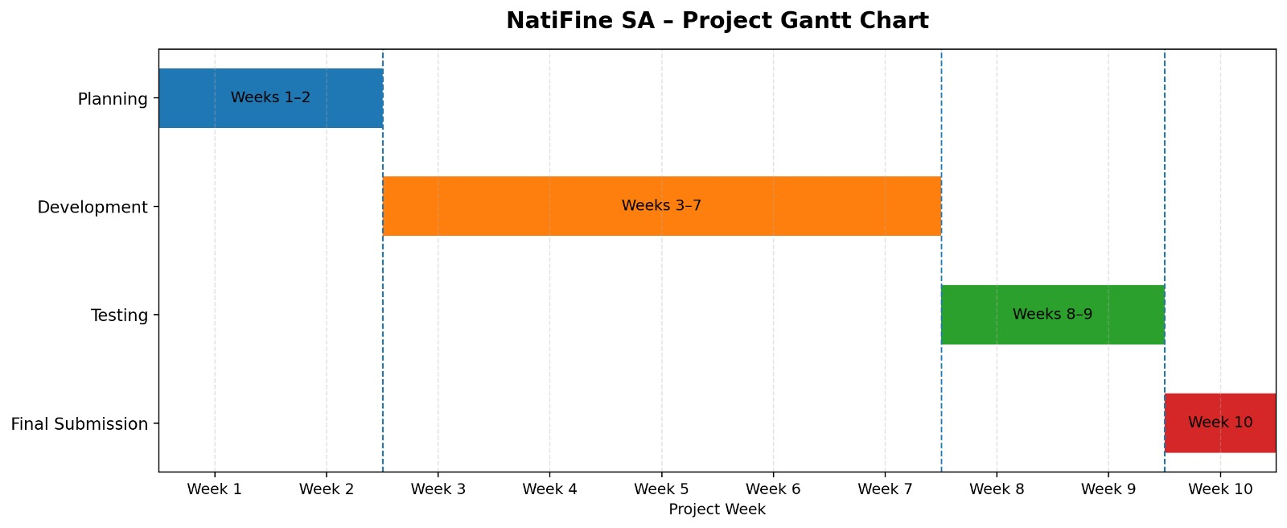
Then the PERT diagram gives more detailed information about the planning phase activities including their relationships, earliest start and finish time, as well as the critical path.
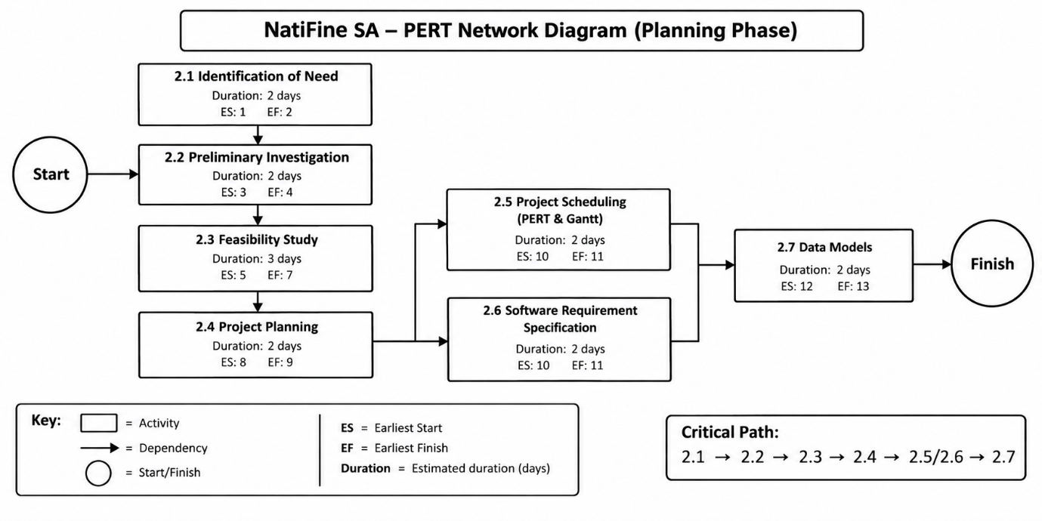

According to the PERT analysis, it can be concluded that Identification of Need (2.1), Preliminary Investigation (2.2), Feasibility Study (2.3), and Project Planning (2.4) need to be completed in a sequential manner as all these phases depend upon the outcome of the previous phase. After completion of Project Planning (2.4), Project Scheduling (2.5) and Software Requirement Specification (2.6) can be completed simultaneously. The Data Models (2.7) can be started only after completion of Project Scheduling (2.5) and Software Requirement Specification (2.6).
The critical path defined is 2.1 → 2.2 → 2.3 → 2.4 → 2.6 → 2.7, which takes 14 days in total. Project Scheduling (2.5) has a float of one day but does not influence the total project duration if completed on time.

2.6 Software Requirement Specification
The Software Requirement Specification (SRS) defines what NatiFine SA should do which is Functional Requirements and the qualities it should have which is Non-Functional Requirements.
Functional Requirements
View Fines: When a user logs in they can view a list of all fines issued against their ID, including date, location, amount and status.
Fine Notification: The system will generate a simulated SMS and WhatsApp-style alert with photo whenever a new fine is added to a user's record.
Online Payment: Users can select a fine and simulate payment through an online payment page.
Dispute a Fine: Users can submit a digital dispute form against a specific fine, attaching a reason and optional evidence relating to that dispute.
Automatic Reminders: The system automatically flags and reminds users of fines left unpaid after a set period.
Admin/Officer Interface: An authorized user (traffic officer/admin) can capture new fines against a motorist's ID number.
License Status Flag: The system flags a user's license status in the database when fines remain unpaid beyond the threshold.
Additional Penalties- When a fine remains unpaid beyond the threshold, the system records an additional penalty amount against the fine, consistent with the penalty escalation described in the Phase 1 proposal.
Non-Functional Requirements
Usability: The interface should be simple enough for a first-time user to view and pay a fine within a few clicks, using clear HTML/CSS layouts.
Performance: Fine records for a given user should load in under 2 seconds on the prototype's test database.
Security: Passwords are stored hashed and only an authenticated person may view or pay a user's fines.
Reliability: The prototype should run without crashing through a full demo scenario for example, register, view, and pay or dispute).
Availability: As an academic prototype, the system needs to be available during development, testing and demo sessions rather than 24/7 in production.
Maintainability: The code will be organised into clear modules (authentications, fines, payments, notifications) to make it easy for the three-person team to maintain.

2.7 Data Models
This model identifies the entities NatiFine SA should retain in its records and how each entity is connected to the other. The following table gives an overview of the principal entities that will make up the prototype database schema; these will be detailed and represented in full entity relationship diagram format in the Development stage of the project.

Entity | Key Attributes | Relationships
User (Motorists) | UserID (PK), IDNumber, Name, Surname, Phone, Email, PasswordHash, LicenceStatus | One user can have many fines and can submit multiple disputes.
Fine | FineID (PK), UserID (FK), IssueDate, Location, Amount, Status, PhotoURL, OfficerID (FK), PenaltyAmount | Each fine belonging to one user and a Fine can have zero or one dispute but many notifications.
Payment | PaymentID (PK), FineID (FK), Amount, PaymentDate, Method, Status | A Fine can have zero or one payment in the prototype, representing a single full payment.
Dispute | DisputeID (PK), FineID (FK), Reason, EvidenceURL, DateSubmitted, Status | A fine can have zero or one dispute.
Notifications | NotificationID (PK), FineID (FK), Type (SMS/WhatsApp), Message, SentDate | A fine can have many notifications, such as an initial alert and payment reminders.
Officer/Admin | OfficerID (PK), Name, Badge/EmployeeNo, Station | One fine or multiple fines can have disputes.

Conceptually, one User can be associated with multiple Fines and for each of these Fines multiple Notifications can be referred to and if a Fine is contested, then there will be one Dispute. The settled Fine will produce one Payment record. For every Fine issued, there should be a record of the Officer/Admin who issues it. This implies that the architecture provides the required features to meet the needs of seeing the fines issued by users, checking payments and dispute statuses and creating notification history for each fine.

